**CSC8502 Advanced Graphics for Games**

**Mark Kostadinov, Student number: 150368616**

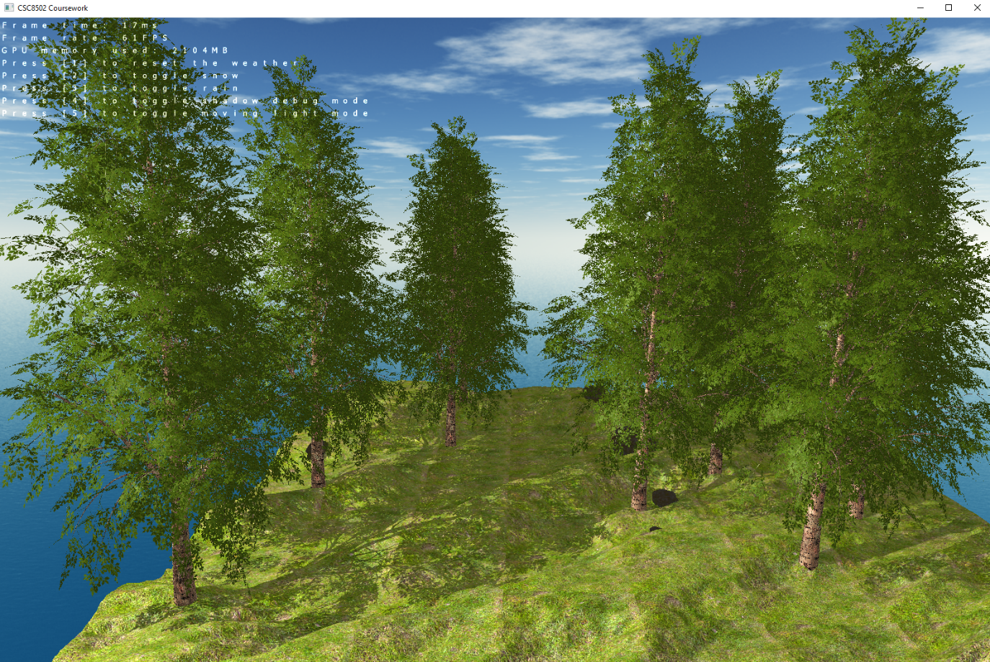

* **First scene:** rendering some randomly generated trees and rocks on a height map. Ambient, diffuse and specular lighting is applied on the whole scene, as well as real-time shadow mapping.

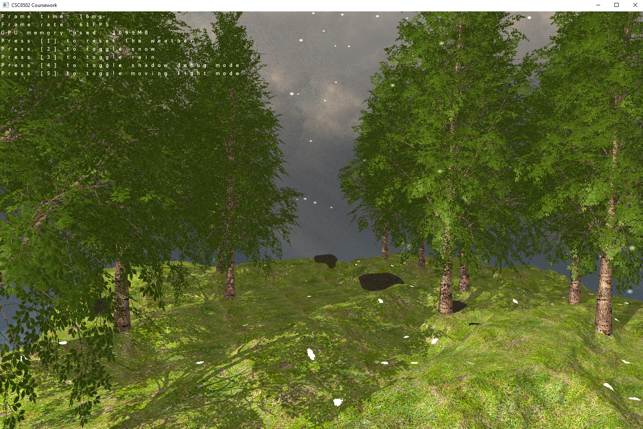

* **First scene:** Snowing effect via a particle emitter. The snowflakes accumulate onto the terrain by changing its texture and also increasing its height over time. Can be counted as a mini-scene.

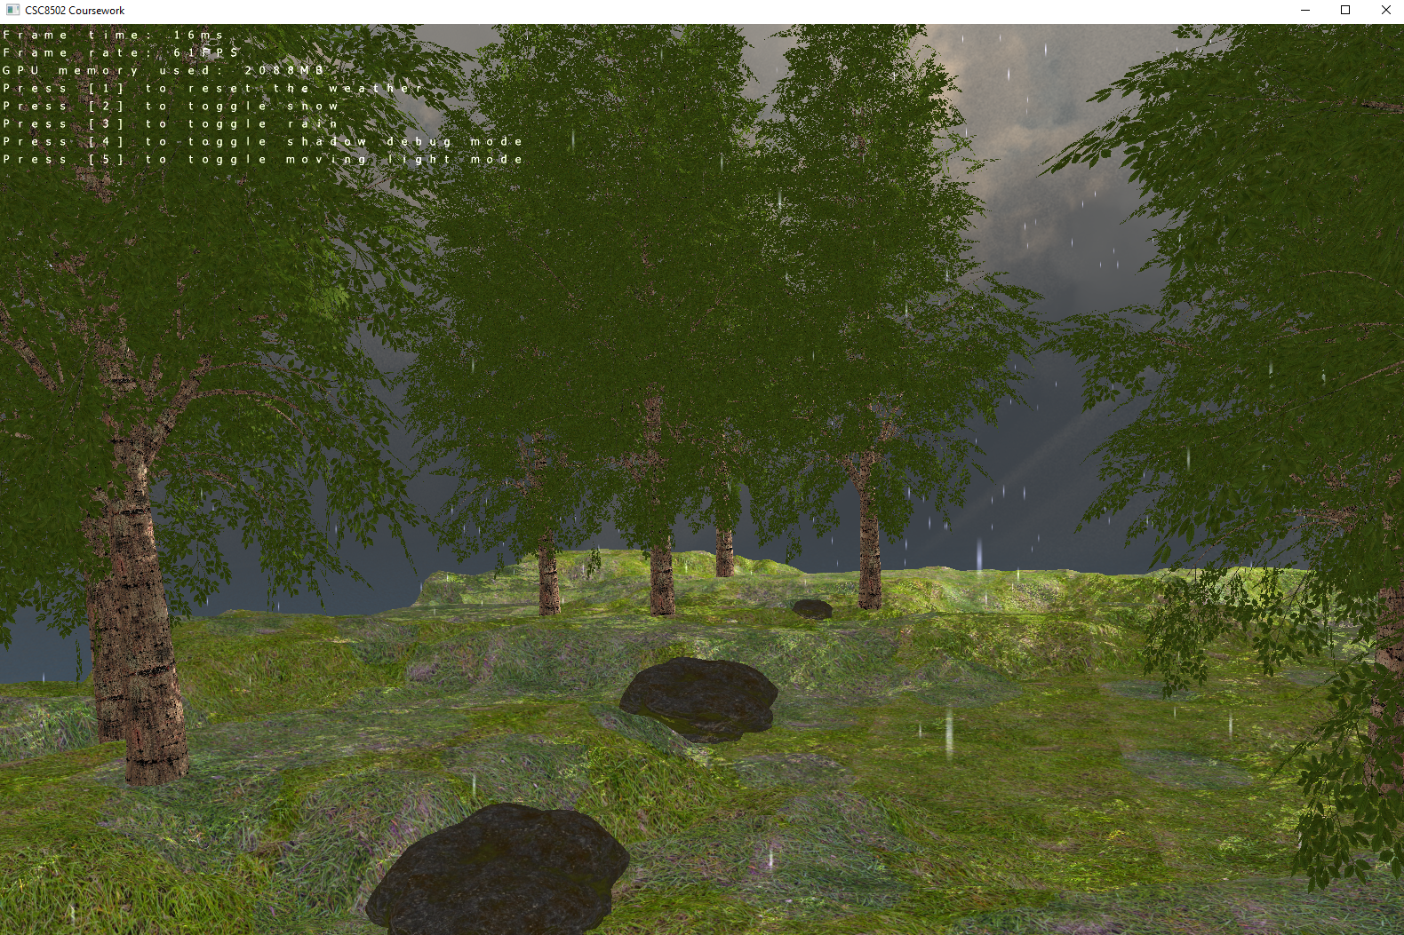

* **First scene:** Raining effect via a particle emitter. The raindrops accumulate onto the terrain by changing its texture over time. Can be counted as a mini-scene.

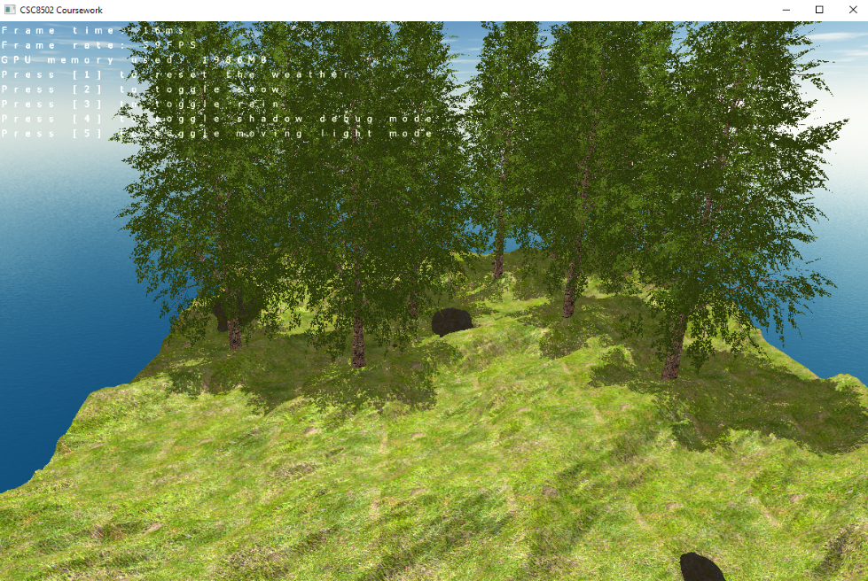

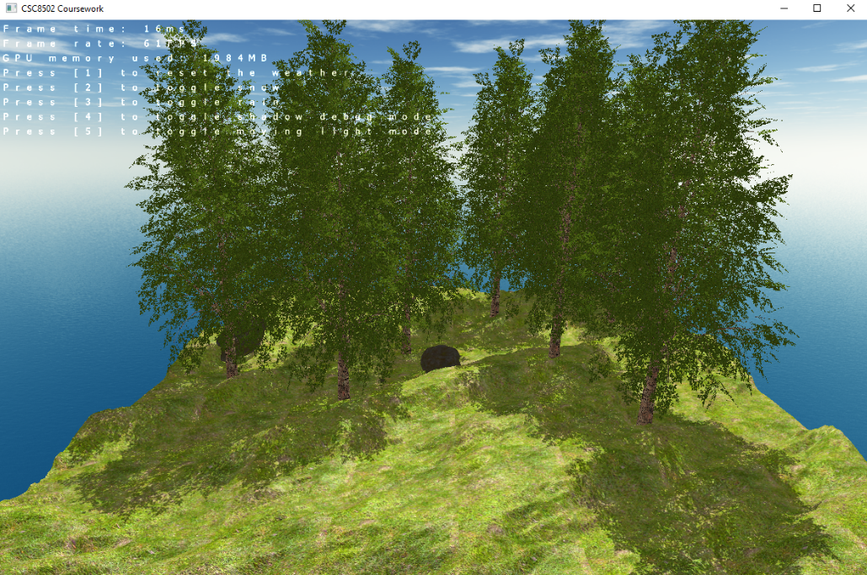

* **First scene:** The moving light mode is toggled on and the appropriate lighting and shadow effects are being applied (i.e. when the light source is moving the shadows of the trees are moving too).

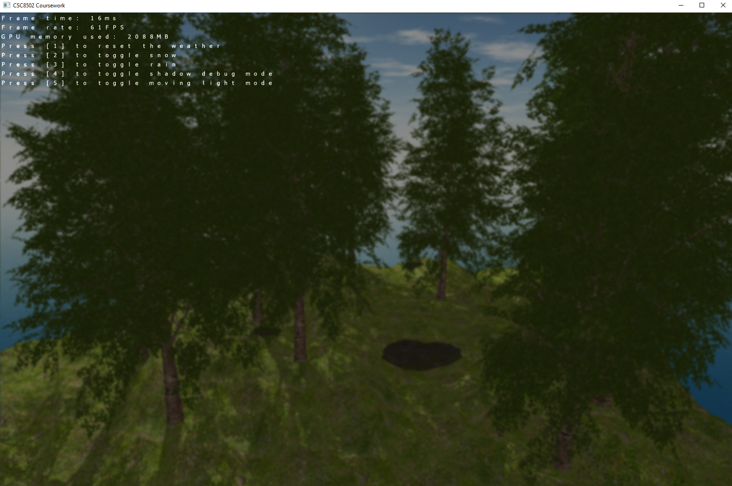

* **First scene:** Transitioning to the next scene by applying a blur and a fade out effect over the period of 5s.

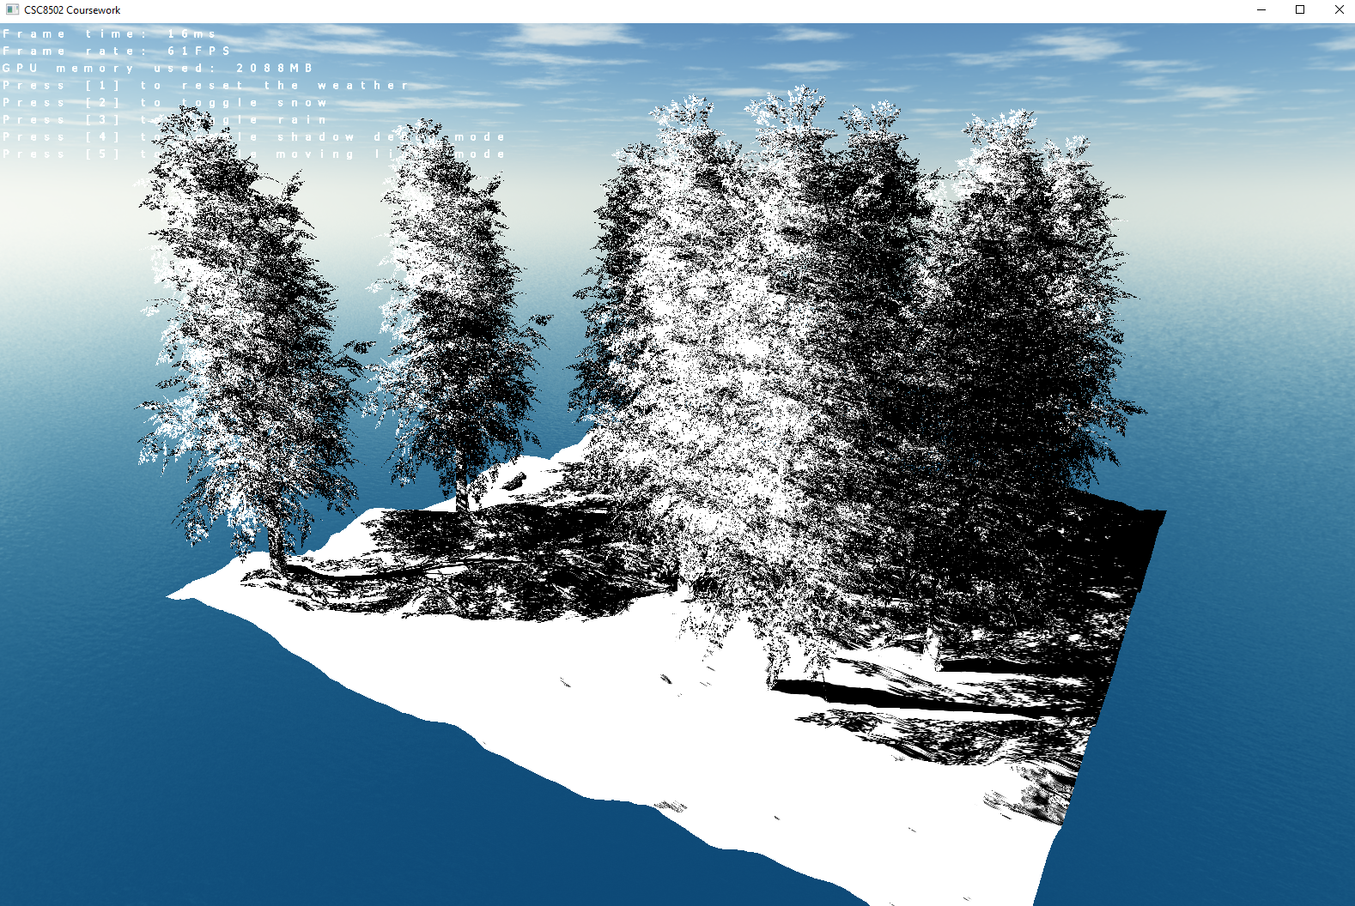

* **First scene:** Shadow debug mode toggled on.

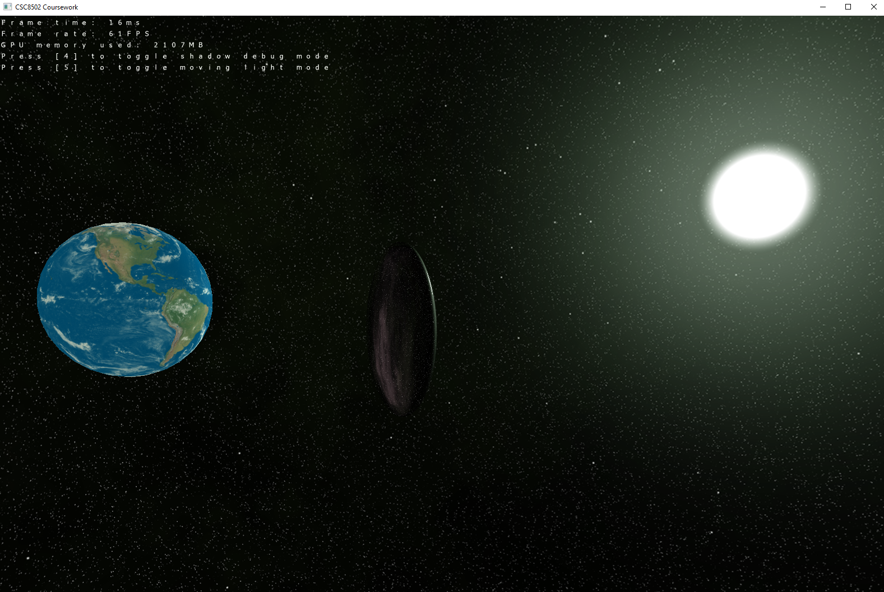

* **Second scene:** A space scene with planet Earth in the center and an UFO orbiting around it. Same lighting and shadow calculations as the previous scene are applied. The surface of the spaceship is reflecting everything around it via environment mapping.

ADD OMNI-DIR

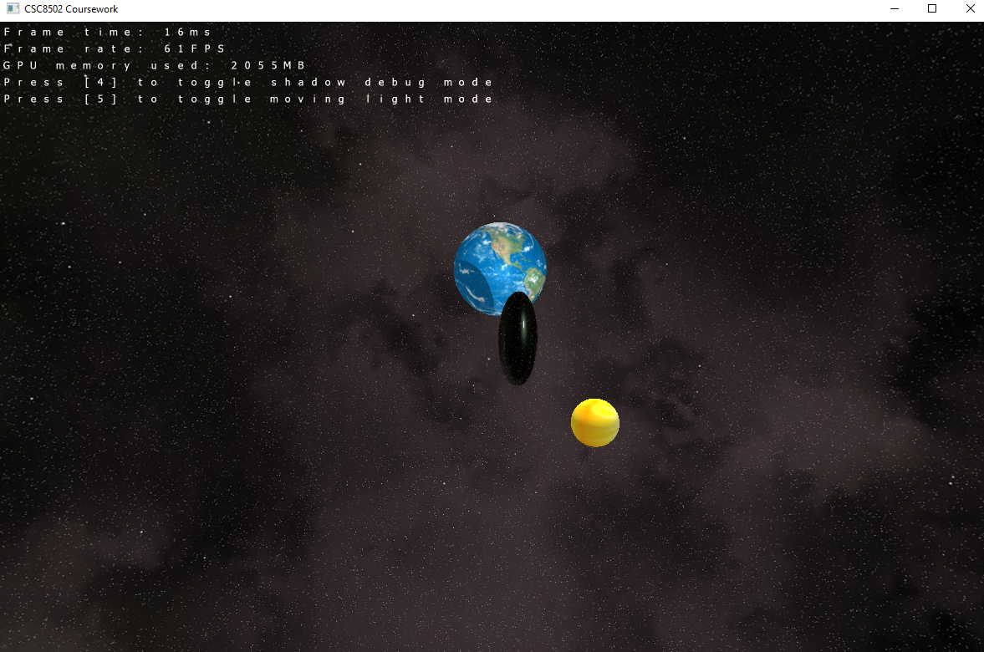

* **Second scene:** A sun is orbiting around the Earth and acting as a moving light source in this scene. It can be observed how the spaceship casts its shadow onto the planet as proof for that.